Solutions for Hands-On Exercises (Data Structures and Algorithms)
Exercise-2: E-Commerce Platform Search Function
- Big O Notation
Big O Notation is used to measure the efficiency of an algorithm by describing how its execution time grows as the input size increases. It helps compare different algorithms and determine which one performs better for large datasets.
Common complexities include:
- O(1) – Constant Time
- O(log n) – Logarithmic Time
- O(n) – Linear Time
- O(n²) – Quadratic Time
2. Searching is the process of finding a specific element in a collection of data.
a) Best Case
The desired product is found immediately.
Example: Searching for the first element in the list.
Time Complexity: O(1)
b) Average Case
The desired product is found somewhere in the middle of the list.
Time Complexity: O(n) for Linear Search

c) Worst Case:
The desired product is the last element or is not present in the list.
Time Complexity: O(n) for Linear Search

- Implementation:
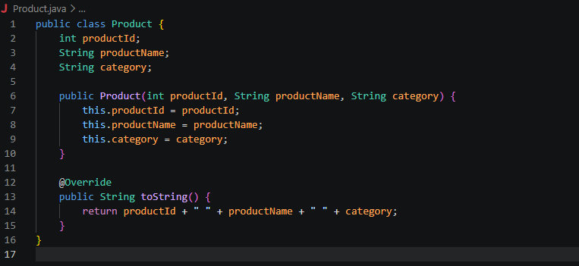
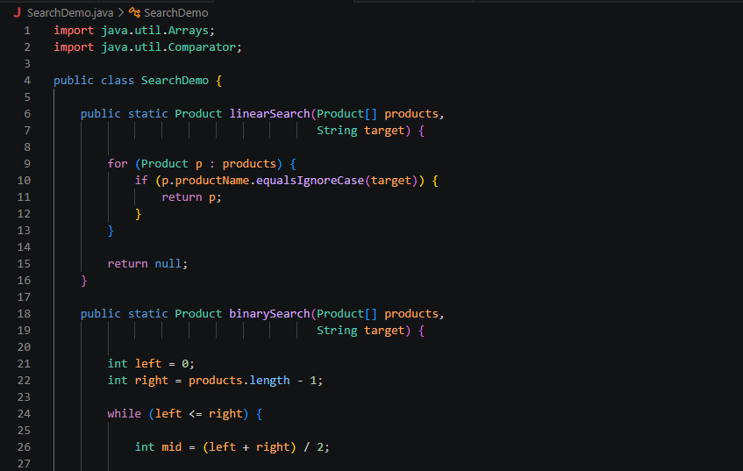
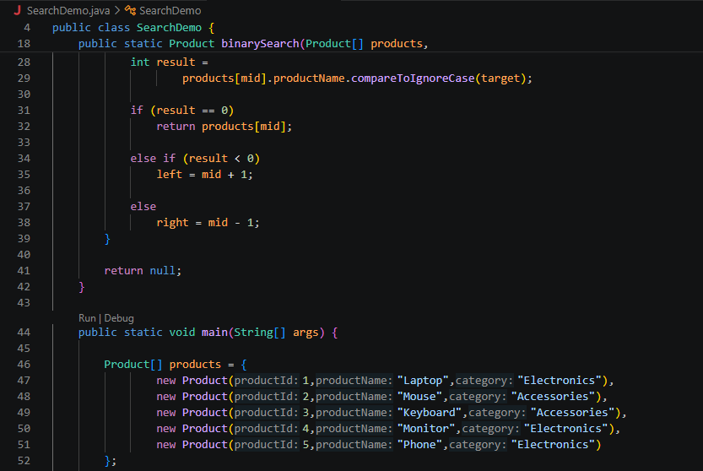
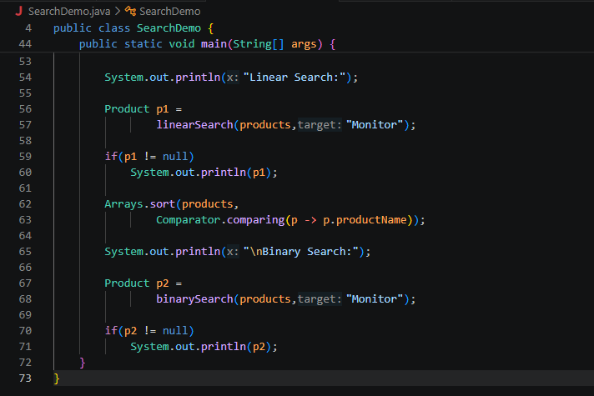
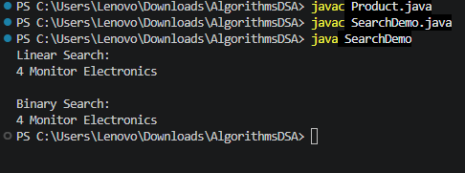

- Analysis:
Linear Search examines each element in the list one by one until the desired product is found. It can be used on both sorted and unsorted data, making it simple and flexible. However, for large datasets, Linear Search becomes slow because it may need to check every element. Its average and worst-case time complexity is O(n).
Binary Search, on the other hand, works only on sorted data. Instead of checking every element, it repeatedly divides the search space into two halves and eliminates the portion that cannot contain the target element. This significantly reduces the number of comparisons required. As a result, Binary Search has an average and worst-case time complexity of O(log n), making it much faster than Linear Search for large datasets.
- What’s better?
Linear Search is suitable for small or unsorted datasets, while Binary Search is preferred for large sorted datasets where fast searching is required. Since e-commerce platforms often contain thousands of products, Binary Search is generally a more efficient choice.

Exercise – 7: Financial Forecasting
- Recursion:
Recursion is a programming technique in which a function calls itself to solve a problem. Instead of solving the entire problem at once, recursion breaks it down into smaller and simpler subproblems of the same type. A recursive function consists of two main parts: the base case, which stops the recursion, and the recursive case, which calls the function again with a smaller input.
Recursion simplifies certain problems because it provides a clear and concise way to express solutions that have a repetitive or self-similar structure. Problems such as calculating factorials, generating Fibonacci numbers, traversing trees, and financial forecasting can be implemented more easily using recursion. By reducing a complex problem into smaller subproblems, recursion often makes the code easier to understand and maintain.
However, excessive recursion can increase memory usage due to multiple function calls being stored on the call stack. Therefore, recursion should be used when it provides a simpler and more intuitive solution compared to iterative approaches.
- Formula:
In this exercise, recursion is used to calculate the future value of an investment based on a fixed annual growth rate. The function repeatedly applies the growth rate to the current value until the specified number of years is reached.
Future Value Formula:
Future Value = Present Value × (1 + Growth Rate)^Years
The recursive solution calculates the value year by year until the base case (years = 0) is reached.
- Implementation:
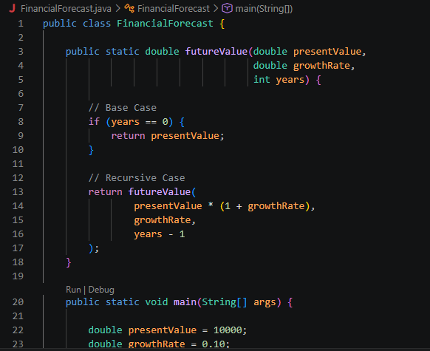
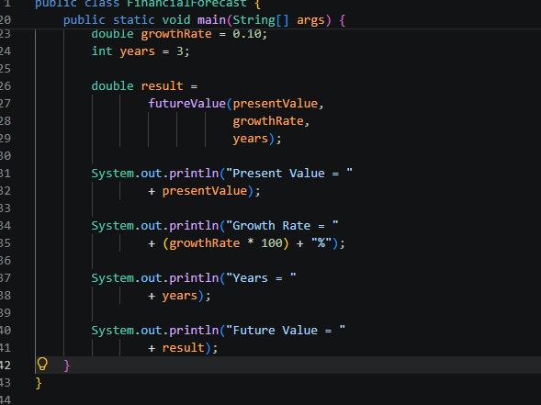
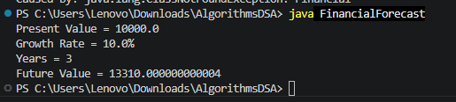

- Analysis:
The recursive function performs one recursive call for each year.
Time Complexity: O(n) ; where n is the number of years.
Space Complexity: O(n)
This is because each recursive call is stored on the call stack until the computation is completed.
Optimization
For large values of n, recursion may consume significant memory due to repeated function calls. The solution can be optimized using:
a) Iteration:
A loop can be used instead of recursion, reducing space complexity to O(1).
b) Memoization:
Previously computed results can be stored and reused to avoid unnecessary calculations.

